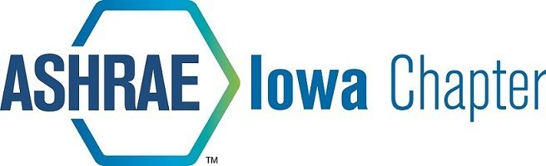

2023-2024 ASHRAE Sponsorship Opportunities
ITEM | DESCRIPTION |  | QTY | UNIT PRICE |  | SUBTOTAL
Newsletter Sponsorship
Annual Sponsorship | Company logo in newsletter each month |  |  | $ 125.00 |  | $ -
YEA Disc Golf Outing | Fall of 2024
Gold Level Sponsor | Hole table / tent |  |  | $ 300.00 |  | $ -
Silver Level Sponsor | Food/prize Sponsor |  |  | $ 200.00 |  | $ -
Bronze Level Sponsor | Hole Sponsor |  |  | $ 100.00 |  | $ -
ASHRAE RP Sponsorship
Honor Roll (Company) | Recognition in newsletter |  |  | $ 500.00 |  | $ -
Honor Roll (Individual) | Recognition in newsletter |  |  | $ 150.00 |  | $ -
Other Amount | Recognition in newsletter |  |  | $ Various |  | $ -
Credit card payments preferred, link here:  For questions or comments, please contact Nick Seymour or Collin O’Brien (ASHRAE RP Chairs) at nick.seymour@trane.com or . Thank you for your continued support of our local ASHRAE chapter! |  | Subtotal |  |  |  | $ -
 |  | Paid |  |  |  | $ -
 |  | TOTAL |  |  |  | $ -
Checks may be made out to ASHRAE Iowa Chapter and sent to the address below:

Name | ASHRAE Iowa Chapter
 | 2024 Sponsorship
Address | PO Box 3686
City, State Zip | Urbandale, IA 50323

