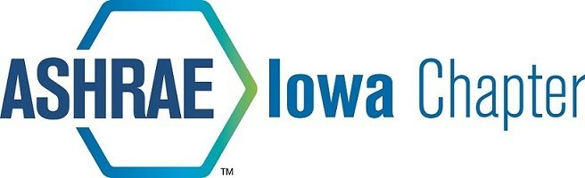

2024-2025 ASHRAE Sponsorship Opportunities
ITEM | DESCRIPTION |  | QTY | UNIT PRICE |  | SUBTOTAL
Newsletter Sponsorship
Annual Sponsorship | Company logo in newsletter each month |  |  | $ 125.00 |  | $ -
YEA Disc Golf Outing | Fall of 2024
Sponsorship | Opt table tent, recognition at event and in newsletter |  |  | $ 200.00 |  | $ Online, see below
ASHRAE RP Sponsorship
Honor Roll (Company) | Recognition in newsletter |  |  | $ 500.00 |  | $ -
Honor Roll (Individual) | Recognition in newsletter |  |  | $ 150.00 |  | $ -
Other Amount | Recognition in newsletter |  |  | $ Various |  | $ -
ASHRAE Spring Fling Golf Outing Pledge | Payment collected later
To Follow | Options to follow |  |  | $ |  | $ -
ASHRAE Fall Frolic Golf Outing Pledge
To Follow | Options to follow |  |  | $ |  | $ -
Credit card payments preferred, link here:  For questions or comments, please contact Nick Seymour or Collin O’Brien (ASHRAE RP Chairs) at nick.seymour@trane.com or . Thank you for your continued support of our local ASHRAE chapter! |  | Subtotal (not including golf outings) |  |  |  | $ -
 |  | Paid |  |  |  | $ -
 |  | TOTAL |  |  |  | $ -
Checks may be made out to ASHRAE Iowa Chapter and sent to the address below:
Name | ASHRAE Iowa Chapter
 | 2024 Sponsorship
Address | PO Box 3686
City, State Zip | Urbandale, IA 50323

Registration for Disc Golf Outing: https://ashraeiowa.org/event-registration/
Registration for Newsletter Sponsorship: Link to follow
Donation to ASHRAE RP: https://www.ashrae.org/about/invest-in-the-rp-campaign
Please mark “ASHRAE Endowed Research” on donation

